TASK 9 – EVALUATE THE MEMORY HIERARCHY AND I/O SYSTEMS
Full Question
Evaluate how data moves between storage levels and devices.
Discuss:
- The levels of memory hierarchy: registers, cache, main memory, SSD, hard disk and network storage with typical access times and sizes.
- Where MRI images, patient records and monitor readings should be kept.
- Programmed I/O, interrupt-driven I/O and DMA, and which suits the MRI scanner.
- The effect of caching on the speed of record lookup.
AIM
To evaluate the memory hierarchy and I/O methods and determine suitable storage and data-transfer techniques for a smart hospital.
ANSWER
1. Introduction
The memory hierarchy is an arrangement of storage devices based on speed, capacity and cost.The fastest storage is generally small and expensive, while slower storage provides larger capacity at a lower cost.
A smart hospital processes different types of data, including patient records, MRI images and continuous patient-monitor readings. Suitable storage and I/O methods are necessary to ensure efficient operation.

2. Memory Hierarchy
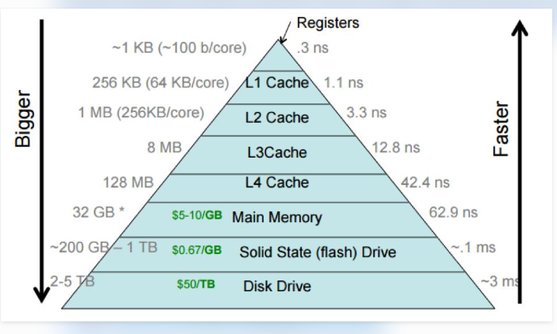

Memory Level | Typical Access Time | Capacity | Main Purpose
CPU Registers | Less than 1 ns | Very small | Immediate CPU operations
Cache Memory | Around 1–10 ns | KB to MB | Stores frequently used data
Main Memory (RAM) | Around 50–100 ns | GB | Running programs and active data
SSD | Around 50–200 µs | Hundreds of GB to TB | Fast persistent storage
HDD | Around 5–15 ms | TB | Large storage capacity
Network Storage | Depends on network | TB to PB | Shared data storage
These are approximate illustrative ranges. Actual values depend on the hardware and workload.
3. Storage of Hospital Data
Data Type | Recommended Storage | Reason
MRI images | SSD and network storage | Large files require fast access and reliable storage
Patient records | Database server SSD with backups | Fast lookup, security and persistent storage
Patient-monitor readings | RAM buffers and database storage | Fast processing and continuous recording
Historical patient records | HDD or network storage | Large capacity and cost-effective long-term storage
Frequently accessed patient data | RAM cache | Reduces lookup time
MRI images should be stored in a medical imaging storage system, such as a PACS, with suitable backups.
Patient records should be maintained in a secure database with access control and backup mechanisms.
4. I/O Methods
A. Programmed I/O
In programmed I/O, the CPU directly controls the data transfer and repeatedly checks the device status.
Advantages:
- Simple implementation.
- Suitable for small data transfers.
Disadvantages:
- Wastes CPU time.
- Inefficient for large transfers.
B. Interrupt-Driven I/O
In interrupt-driven I/O, the device sends an interrupt when it needs CPU attention or when an operation completes.
Advantages:
- Reduces unnecessary CPU polling.
- CPU can execute other tasks.
- Suitable for devices with occasional events.
Disadvantages:
- Interrupt handling introduces overhead.
- Many interrupts may affect performance.
C. Direct Memory Access (DMA)
DMA allows a device to transfer data directly between the device and main memory without requiring the CPU to transfer each byte individually.
Advantages:
- High transfer speed.
- Reduced CPU involvement.
- Efficient for large data transfers.
Disadvantages:
- Requires DMA-capable hardware.
- Requires careful memory and device coordination.
5. I/O Method Suitable for MRI Scanner
An MRI scanner generates large amounts of image data.
Therefore, DMA is the most suitable method for transferring MRI data from the imaging device into main memory.
DMA reduces CPU workload and improves transfer efficiency.
Interrupts can be used to notify the CPU when the DMA transfer is completed.
6. Effect of Caching
Caching stores frequently accessed data in faster memory.
For example, a doctor may repeatedly access a patient's recent test results. If the information is stored in RAM cache, it can be retrieved faster than reading it from SSD or network storage.
Advantages of caching:
- Faster patient-record lookup.
- Reduced storage access.
- Reduced network traffic.
- Improved database performance.
However, cached data must be updated or invalidated when the original records change to prevent stale information.
7. Alternative Concept – Interrupt-Driven I/O Versus DMA
If the MRI scanner transfers a 500 MB file using interrupt-driven I/O, the CPU may need to handle many interrupts during the transfer.
With DMA, the device transfers the data directly into memory and may notify the CPU after completion.
Factor | Interrupt-Driven I/O | DMA
CPU involvement | Higher | Lower
Large transfer efficiency | Lower | Higher
Interrupt frequency | May be high | Usually lower
Transfer method | CPU handles device data | Device transfers to memory
MRI suitability | Less efficient | Highly suitable

CONCLUSION
The memory hierarchy improves system performance by placing frequently used data in faster storage. Patient records should be stored securely in a database, MRI images should use high-capacity persistent storage, and recent monitor readings should be processed in memory. DMA is recommended for MRI data transfer because it reduces CPU involvement and improves efficiency.
Screenshot Instructions
Paste the screenshot of the completed answer and the memory-hierarchy diagram if you are including one.

